**Tutorial 6 – ChatBot**

In this exercise we will we creating a ChatBot that potential/future tourists can ask questions to, about Malta.

For this purpose, the FAQ section of VisitMalta, as seen here:

<https://www.visitmalta.com/en/info/malta-faq/>

have been copied onto 2 text files, one with questions and the other with answers. These will be provided to you.

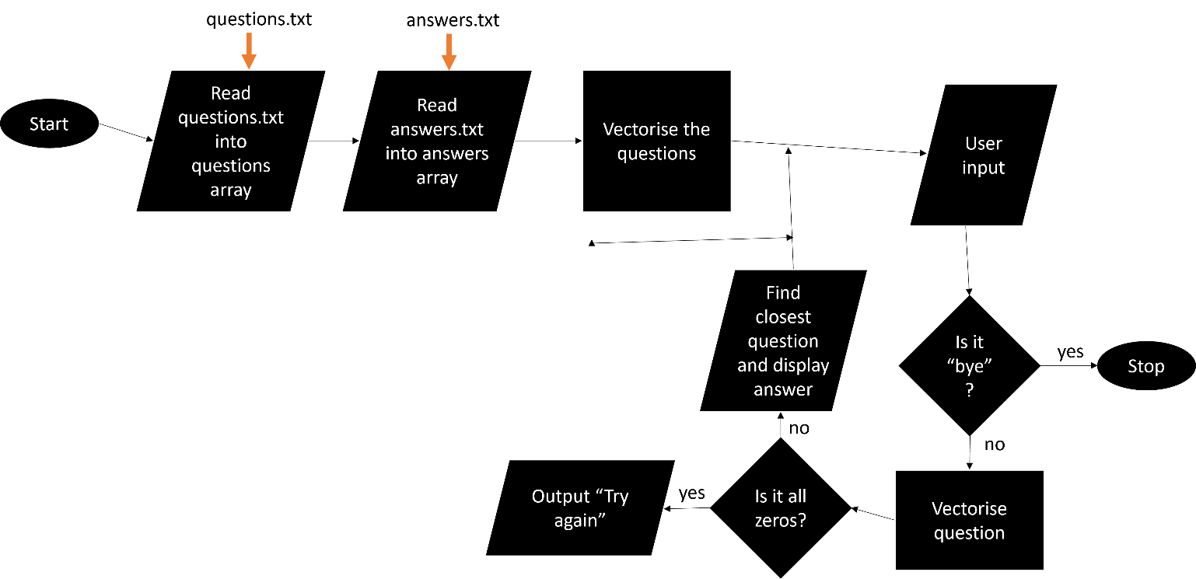

The following steps will help you:

1. Create an array/list called *questions* and another called *answers*. Read the contents of the text files into the arrays, such that each question and answer are found in the same index in the 2 lists.
2. Use a CountVectorizer (set to eliminate stopwords) and use it to create the count vectors for each question in the *questions* list.
3. In a loop, ask the user to input any question, or else type ‘bye’ to exit
4. If the user enters a question, find its vector, using the same bag of words (same vectorizer) as used when processing the *questions* list.
5. If its vector contains only zeros, output “Sorry, I don’t get that! Try again”
6. If vector is non-zero, use the cosine similarity to calculate the closest question in the questions list (most similar to the user input).
7. When you find it, display its answer.
8. The process should then repeat, and only stop when the user types “bye”.

